VEX IQ Level Up: Session 4 - Dots and Boxes

Activity: Play Dots and Boxes to practice developing a strategy.

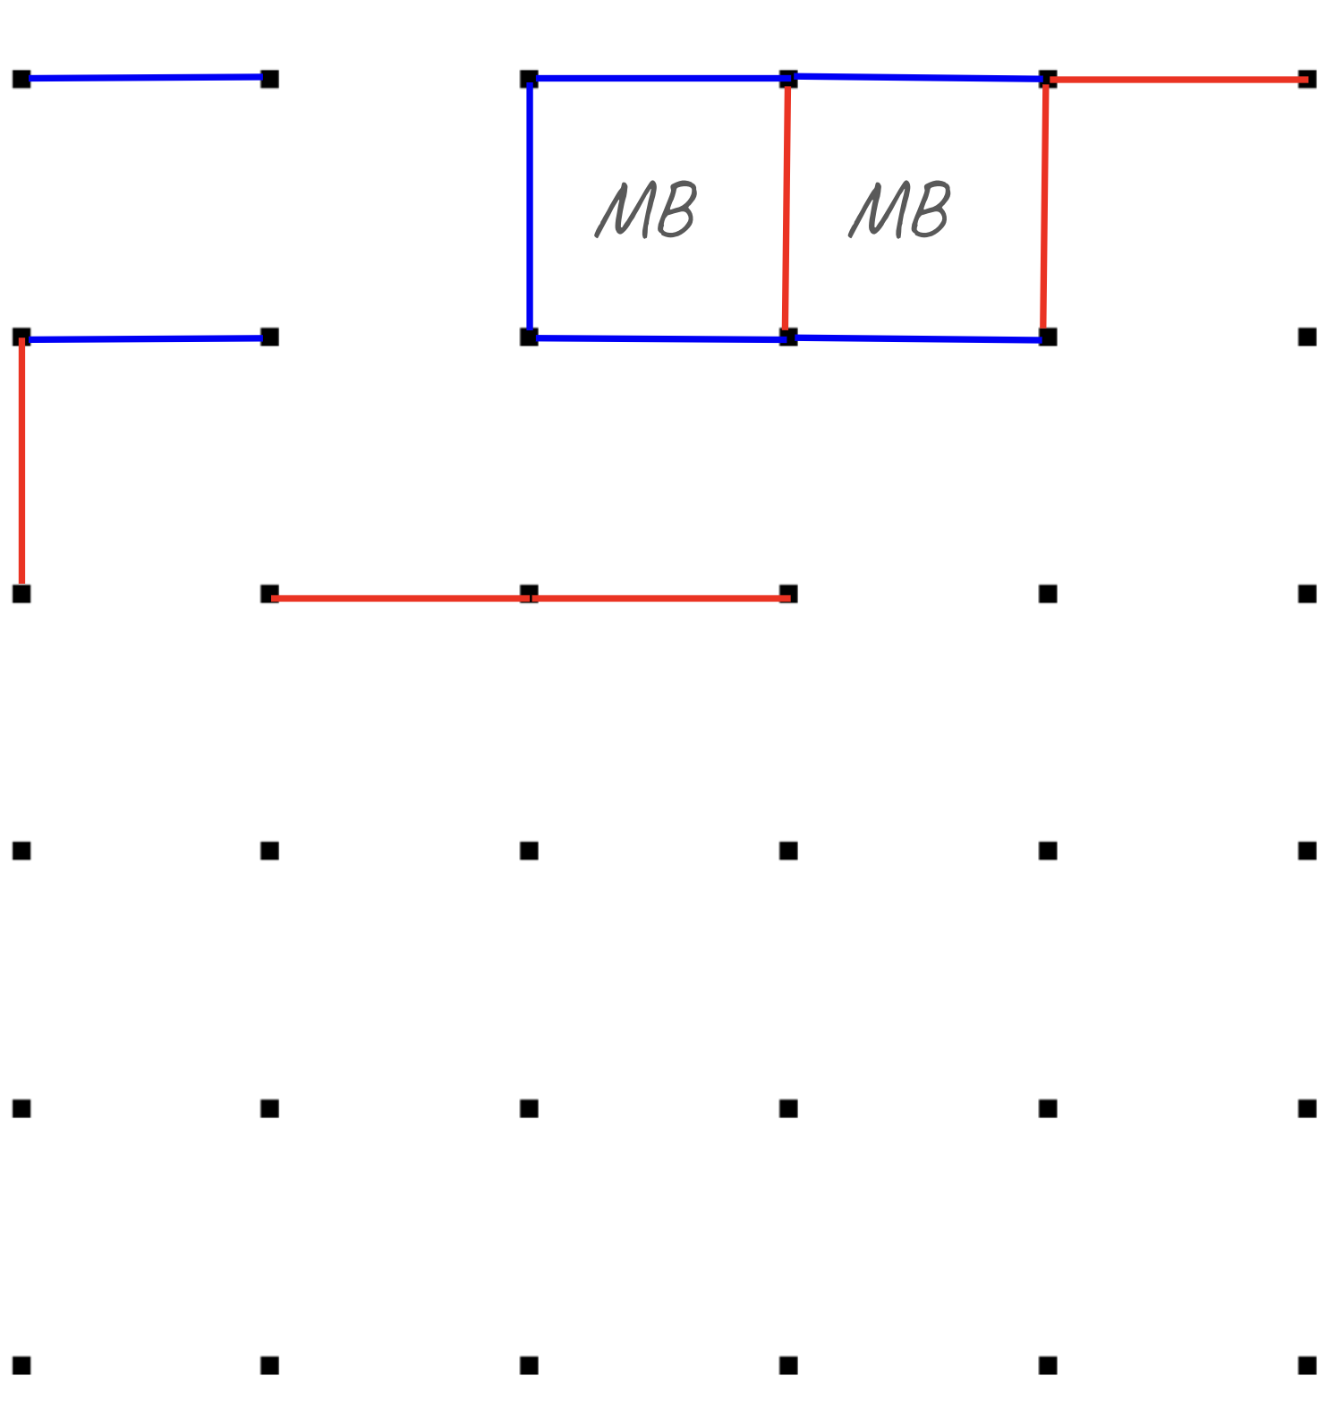
You are going to apply the process from the video to play Dots and Boxes (rules to the game are included on the next page of this task card).

- STOP to explore and prepare for the game, using the following checklist. Discuss your ideas with your partner.
- What are the rules of this game?
- What questions do I have about the rules or the game setup?
- How can I find the answers to questions I have about this game?
- Who can help me if I am stuck?

- THINK creatively to develop as many strategies as possible for winning the game. Discuss your ideas with your partner.

- TEST by choosing the strategy you like best, and playing Dots and Boxes.

- EVALUATE your strategy using the following checklist:
  - How well did your strategy work?
  - How would you change your strategy to make it more effective next time?
  - Can you think of an even better strategy, now that you have played the game?
  - What did you learn from this round of strategy development?

Activity Checklist

- Each team member shared and discussed what they knew about the game.
- Each team member shared strategy ideas.
- The team played Dots and Boxes to test a strategy.
- Each team member contributed to evaluating their strategies.

How to Play Dots and Boxes

Number of Players: 2

Object of the Game: Capture as many boxes as you can.

Gameplay:

- Each player chooses a different color of pen.
- Player 1 connects two adjacent dots either vertically or horizontally. No diagonal connections are allowed in this game.
- If a player draws the fourth side of a box, they 'capture' that box and write their initials inside. If a player captures a box, they get another turn.
- The game is over when all the boxes have been captured.
- The player who captures the most boxes, wins!


